Name
Tutor
Course
Date
Theories about International Institutions
In understanding the International institutions or organizations, international relations are key. International organizations foster the interdependence of different countries. These institutions have shaped a way through which international relations are carried out by the different participants or actors. These institutions therefore formulate rules and regulations that govern the activity and behaviour of various actors in the international scene (Levi & Nicola, 2014). Various theories have been formulated to explain international institutions. They include the realist approach, liberal approach and the constructivist approach.

From a realist point of view, international institutions are not important compared to the states they represent but they only function for the interests of the member states. The main focus of this approach is power and security relating to the states in the international stem. Liberal approach on the other hand argues that international institutions are formed to enhance the collective welfare of individuals. These institutions make this possible through the establishment of commitments, provision of goods and information collection. Constructivists argue that international institutions are not necessarily tailored towards issues of power and security but rather the relationships involved depend more on the members or actors. This relationship will be governed by the way the actors view various issues in the world (Levi & Nicola, 2014).

International Monetary Fund (IMF)
This institution was formed in 1945. Its main function is to promote international cooperation through stabilizing exchange rates thus enabling the growth of international trade among member countries helping them maintain a balance between poverty conditions and payments (Levi & Nicola, 2014). A total of 187 countries hold membership of this institution. The board of governors is the top authority of IMF. These governors are usually finance minister of governors of the central bank of the respective countries. The institution runs on its own structure and governance though it is a United Nations component. There is also and executive board comprised of 24 members headed by a managing director elected through a voting process. The institution governs the monetary policies of its members and also provides financial advice. Through surveillance, IMF monitors economic stability. This done through obtaining economic reports from member countries and presenting them to a board that analyses them from a global point of view.
World Bank (1995)
This is an international financial institution that gives loans to various countries in the world to help fund capital projects. It is made up of two institutions; the International Development Association and the International Bank for Reconstruction and Development. In terms of structure, this institution is run by a board of directors made up of 25 executive directors and the group president. The vice presidents usually act as the managers of regions and networks; the institution has two executive Vice presidents, three Senior Vice presidents and 24 Vice presidents. The directors as individuals cannot exercise power or represent the bank unless authorised to do so (Gilbert & David, 2014).
World Trade Organization (WTO)
This is an institution that is concerned with the rules that regulate trade between nations. It is aimed at ensuring that exporters, importers and producers of goods and service conduct their business efficiently. The ministerial conference made up of all the WTO representatives is the highest authority. It meets every two years at least making various decisions regarding multilateral trade agreements. The general council usually run the day to day operations of this institution whilst reporting to the ministerial conference. The general council then delegates duties to councils for Trade in Services, Trade Related Aspects of Intellectual Property and Trade in Goods (Yotov & Mario, 2012).
The graph below shows the link between free trade and global economic growth;
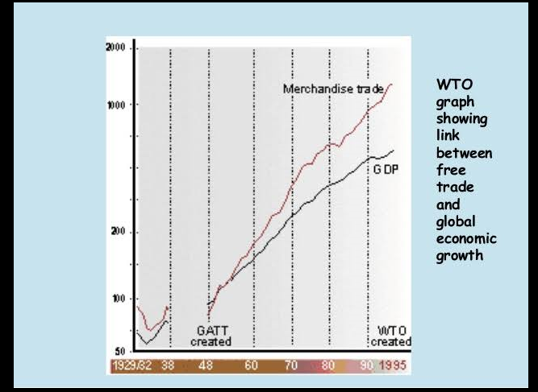
United Nation Conference on Trade and Development (UNCTAD)
This institution was formed in 1964. It is a part of the United Secretariat. The maximization of trade, development and investment opportunities in developing countries is its main aim. It formulates policies that relate to trade, transport, finance, technology and aid. It comprises of 195 member states. It is run by a board of governors. It also comprises of four commissions that operate under the mandate of the board (Levi & Nicola, 2014).

Problems in the Social, Economic, and Political Sphere of human activity
The functions of IEIs have been affected by the various spheres of human life. Socially, different cultures of the various countries have led to slow implementation of certain policies set by these institutions. Economically, the under developed countries are not able to match the strength of the developed countries on certain matters such as capital and technology. Politically, political instabilities among member some of the member countries has hindered the proper functioning of these institutions.
However, these problems can be solved by tailoring the functions of these institutions towards empowering the under developed countries. This way the functions will be easily executed whilst ensuring social, economic and political equality across all the member nations.

Works Cited
Gilbert, C L, and David Vines. The World Bank: Structure and policies., 2014. Print
Levi, Lucio, Giovanni Finizio and Nicola Vallinoto: The Democratization of International Institutions: Fist International Democracy Report., 2014. Print
Yotov, Yoto V, Roberta Piermartini and Mario Larch. An Advanced Guide to Trade Policy Analysis: World Trade Organization. 2012. Print

